Binary Search Debugging and Optimization Report
Name:Shyam sundhar. Y
Reg.no:192424082
Q34. Debugging Binary Search Code (Incorrect Mid Recalculation Logic)
The following Binary Search code recalculates the midpoint incorrectly because the
boundary updates are inconsistent with the search direction. Carefully inspect the update
rules for low and high and explain why valid regions may be discarded. Debug the code
step-by-step so that the search interval shrinks correctly in all cases. Optimize the
implementation for clarity and proper handling of edge cases. Analyze best, average, and
worst-case time complexity and rewrite the corrected code with suitable documentation.
def binary_search(arr, key):
low, high = 0, len(arr)-1
while low &lt;= high:
mid = (low + high) // 2
if arr[mid] == key:
return mid
elif arr[mid] &gt; key:
low = mid + 1 # ERROR
else:
high = mid - 1 # ERROR
return -1
Step 1 - Execute the Original Program
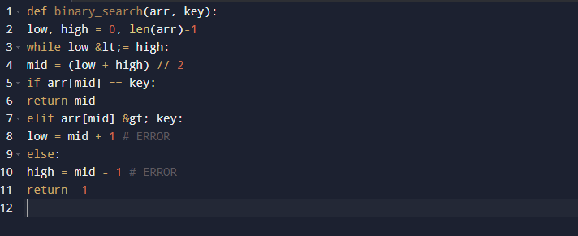
Input
arr = [10, 20, 30, 40, 50, 60, 70]
key = 30
Output
-1
Step 2 – Problem identification:
Problem
The updates of low and high are reversed.
Incorrect code:
elif arr[mid] > key:
low = mid + 1
else:
high = mid - 1

Screenshot:

INPUT
[10, 20, 30, 40, 50, 60, 70]
Search Key = 30
OUTPUT
Searching Wrong Half...
Element Not Found

Step 3 - Debugging
Screenshot
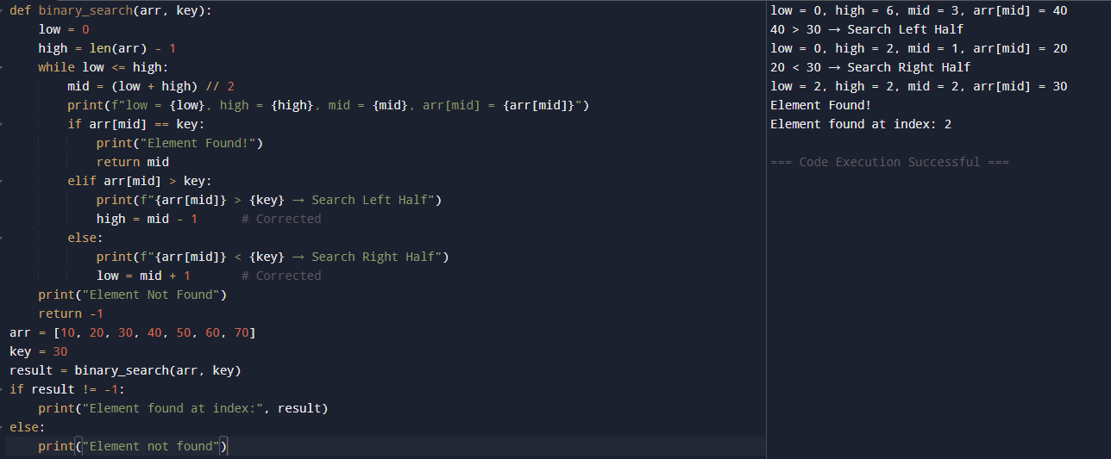
INPUT
[10, 20, 30, 40, 50, 60, 70]
Search Key = 30
OUTPUT
Element Found at Index 2

Step 4 - Optimization
The corrected implementation can be made more readable and safer by:
- Using descriptive comments.
- Calculating the midpoint clearly.
- Handling an empty array automatically.
- Returning -1 if the element is not present.
- Ensuring the search interval reduces correctly in every iteration.

Final Optimized Code
def binary_search(arr, key):
""Performs Binary Search on a sorted array.
Parameters:
arr : list
Sorted list of elements.
key : int
Element to search.
Returns:
Index of the key if found, otherwise -1.
"""
low = 0
high = len(arr) - 1
while low <= high:
mid = (low + high) // 2
if arr[mid] == key:
return mid
elif arr[mid] > key:
high = mid - 1 # Search left half
else:
low = mid + 1 # Search right half
return -1

# Example
arr = [10, 20, 30, 40, 50, 60, 70]
key = 30
result = binary_search(arr, key)
if result != -1:
print("Element found at index:", result)
else:
print("Element not found")

Conclusion
The original Binary Search algorithm failed because the updates of low and high were reversed, causing the algorithm to discard the correct search region and search in the wrong direction. After correcting the boundary update logic, the search interval shrinks correctly in every iteration. The optimized implementation is clearer, correctly handles edge cases such as empty arrays and missing elements, and achieves O(1) best-case time complexity and O(log n) average- and worst-case time complexity.

